WEB SCRAPING IN R

STAT – 260
Haolun Shi
Simon Fraser University

By
Varsha Medhana Adusumalli

One of the most important skills for a data scientist is the ability to find and collect the right data to solve a problem effectively. In a lot of cases, we might not have completely done data sets to work with. To overcome these problems, we need to gather data from the right resources. There are several ways to do this, but two of the most common methods are APIs and Web-Scraping.
- APIs (Application Programming Interfaces) :
These are a set of tools and methods that allow us to request and retrieve data dynamically from a system or website. Many companies such as Google and Apple provide APIs to access their data.
A very well-known example is TransLink, which provides real-time transit updates. TransLink retrieves live traffic and travel data from Google, processes it, and then presents a user-friendly version that helps people plan their routes efficiently.

- Web-Scraping :
Some of the data is not available through APIs or structured data sets but can be directly accessed through websites. Web scraping is the process of extracting information from web pages to collect and organize useful data. This is particularly useful when a website does not offer an API but still has valuable information that can be gathered for analysis.
Web scraping in R can be done using various packages such as rvest, RSelenium, and RCrawler. Among these, rvest is the most commonly used package due to its simplicity and effectiveness.
To begin with basic web scraping, let's explore how to extract information such as country names, populations, and continents from the United Nations' list of countries by population available on Wikipedia.
To get started with this we need to set up R for web-scraping
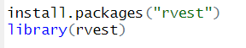
Before diving into web scraping of countries, names and continents , here are some basic functions you should know:
- read_html(url): This function helps us load the HTML content of a webpage (like Wikipedia) into R so we can work with it.
- html_table(): After loading the HTML, this function converts the table we find on the page into a data frame. A data frame is much easier to manipulate and analyze in R.
- html_node(): This function allows us to extract a specific element, or "node," from the HTML document. For example, we can use it to grab the first table on a page.
- country names, populations, and continents

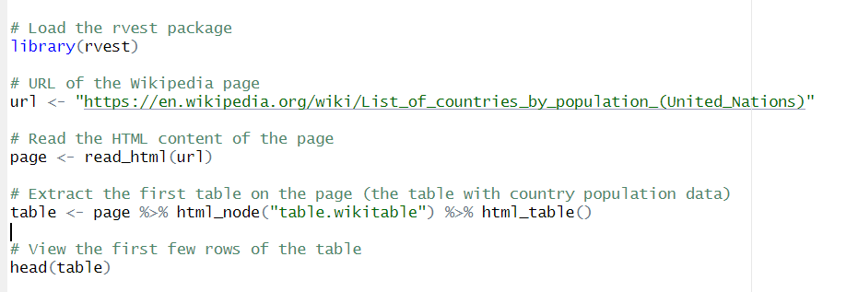
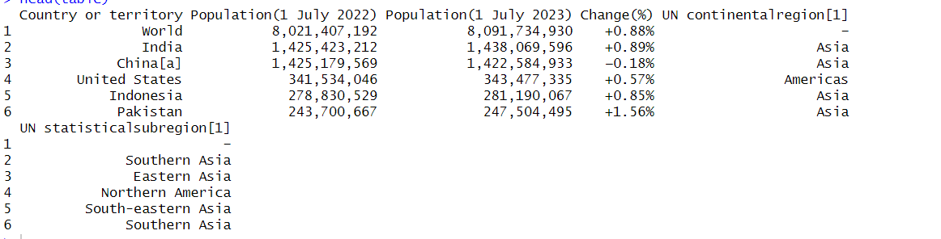
This is the output we’ll get, presented in a simple and clear format as a data frame.
This code loads the rvest package and reads the HTML content of a Wikipedia page that lists countries by population. It then identifies and extracts the first table on the page, which has the class wikitable. To find the class, you can right-click on the webpage, select "Inspect," and then right-click on the element you're interested in to view its class in the HTML structure. The table is then converted into a data frame using html_table(), making it easier to manipulate in R. Finally, the code displays the first few rows of the extracted data to give a preview of the table's contents.
- For the second example, we can try web scraping Craigslist to gather rental price data for the Greater Vancouver area.

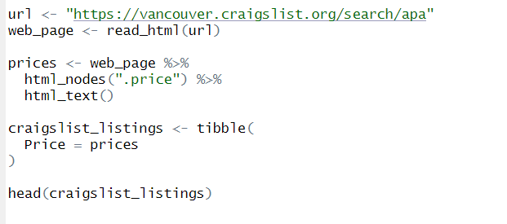
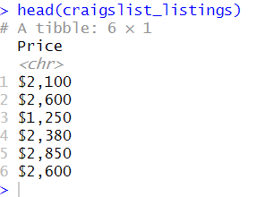
This R script scrapes rental prices from Craigslist for Vancouver. It starts by defining the webpage URL and using read_html() to load its content. The html_nodes(".price") function selects elements with the class .price, which contain the rental prices. The html_text() function extracts the price values as text. The extracted prices are then stored in a tibble (a structured table) with a column named Price. Finally, head(craigslist_listings) displays the first few rows of the collected data. This provides a quick way to analyze rental prices in the Vancouver area.
- For the third example, let's try extracting Olympic medal data from a website where the data is stored in a table with the class name "table".
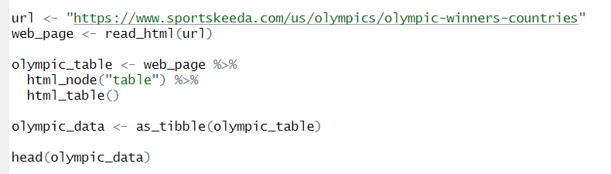
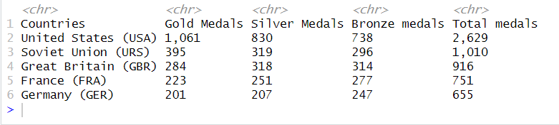
This R script scrapes Olympic medal data from Sportskeeda. It first loads the webpage using read_html(url), then extracts the first table with html_node("table"). The html_table() function converts this table into a dataframe. Next, as_tibble(olympic_table) transforms it into a tibble for easier handling. Finally, head(olympic_data) displays the first few rows. This dataset contains the total Olympic medals won by each country, including gold, silver, bronze, and overall counts. The data can be further analyzed to find top-performing nations.

In this project, we explored the basics of web scraping in R, focusing on extracting data from websites and using it for analysis. Web scraping allows us to collect valuable information from web pages, which can be further processed to solve complex problems and support data-driven decision-making.
We primarily used the rvest package in this project, demonstrating how to extract structured data, such as rental listings from Craigslist, Olympic medal records. This project serves as a foundation for more advanced web scraping tasks, allowing us to gather and analyze web data for research, business insights, and machine learning applications.

References:
Rvest, https://rvest.tidyverse.org/
Web Scraping Using R Language,(Feb,2023),https://www.geeksforgeeks.org/web-scraping-using-r-language/
Websites Used for Scrapping:
https://en.wikipedia.org/wiki/List_of_countries_by_population_(United_Nations)
https://vancouver.craigslist.org/search/apa
https://www.sportskeeda.com/us/olympics/olympic-winners-countries

